13th January 2023

Dear Parents and Carers,

We are delighted to share our Ofsted report from their visit to the school in November.

As you read it, we hope you will get an overwhelming sense of all of the great work that goes on at Western House Academy. Our guiding principle, many years ago, was to provide a values-based education that prepares our children well for life beyond WHA, and this was recognised consistently throughout the inspection.

Western House Academy continues to be a GOOD school.

There is much in the report for us to celebrate and be proud of:

- There is a strong safeguarding culture; we keep the children safe; they know how to stay safe and any concerns are acted on promptly;
- Pupils were seen to behave well in class and around the school; they enjoyed being given responsibility and they felt that their school is friendly and that the teachers are helpful and kind;
- The curriculum is ambitious and meets the needs of all our children;
- The school excels in providing a wide range of academic and extra-curriculum activities for the children, and they are given a broad range of experiences to help them develop into active citizens.

The report offers two areas that could be further developed, but neither were raised on the day as significant cause for concern. They do not detract in any way from the overall and overwhelming positivity of the report.

We would like to take this opportunity to say a personal thank you to all of you for the support we received during the inspection, from the kind words of encouragement on the gates to the positive and honest responses on Parent View.

Our motto at Western House is that ‘every opportunity shapes a life’. Ofsted has squarely confirmed that we are living up to that motto, and our aim from here is to make our great school and community even greater.

Kind regards,

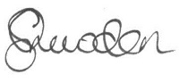
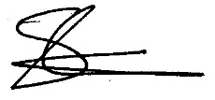

Mrs C Snowden Mr S Carter
Principal Chair of the Academy Council

